**4. Adding a Welcome File**

**Adding a welcome file**:

Now we add a welcome file in our project. Every time we run our project; we are seeing an error page. Now we add a welcome page and that page will redirect to the customer-list page.

**Welcome File**:

<http://localhost:8080/spring-mvc-crud-demo>

1. Server will look for a welcome file
2. If it doesn’t find one, then you’ll get 404
3. Welcome files are configured in web.xml

In the web.xml file we the have two entices.

<welcome-file-list>

<welcome-file>index.jsp</welcome-file>

<welcome-file>index.html</welcome-file>

</welcome-file-list>

“index.jsp” and “index.html”. The server wants to look for these files in a top down fashion.

Now we create our welcome file name “**index.jsp**”.

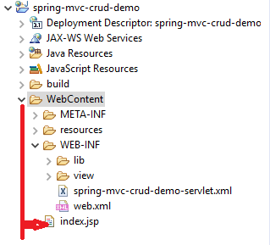

In the “**index.jsp**” page add the following line of code.

<%response.sendRedirect("customer/list"); %>

Now if we run our program this “**index.jsp**” page redirect the “**customer-list page**”.

4. Adding a Welcome File